Motivators Notes
Motivators: what we believe influences how we behave
- Our motivation leads to decisions, then to actions
- Our personal agenda, what we want, what we believe is most important, and how we believe the results should unfold
- Filter our decisions – influence equally high and low scores, but the highest and lowest have the most impact
- Interpret graphs as a whole for accuracy, and always consider DISC for most accuracy
- Sometimes we act in ways we don’t want to (so DISC may not always align with Motivators)
The Gypsy Spirit
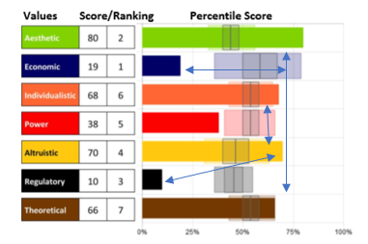
AESTHETIC – Alternative
A drive for balance, harmony and form.
Creative, alternative, imaginative, artsy, mystical and expressive, this style may redefine and resist real world approaches to current problems and challenges.
- Very High - Need for Self-Expression
Very Low- Sensible goals with real world applications
- Creativity -being creative brings value- contributes to beauty and balance
- Out of the box ideas and approaches
- Unconventional thinkers: influenced by how the outside makes them feel
  - High - Not practical, not real-world thinkers
  - Scores Over 75 – typically alternative lifestyle choices (no tv, vegetarian)
  - Creative V (High AES, low ECO, High IND)– there is something they are passionate about that they use to express themselves (art, music, sports, etc)
Examples of interactions-
  - Very High AES, Very High THE – experimental people, unexpected, alternative lifestyles
  - High AES, High THE – creative problem solvers for tough complex problems
  - High AES and Low REG – wants to make a statement
add high D – in your face
or high S – not obvious

ECONOMIC – Competitive
The Entrepreneur

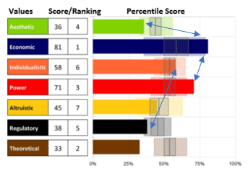
A drive for economic or practical returns.
The drive for security through self-interest and economic gain, to achieve real-world returns on personal and professional ventures.

- Very High - Need to know what’s in it for them, self-interest
Very Low – Need for selflessness
- Competitive, usually have their own agenda
- Return on investment may include time, energy, money, or resources
- Future focus – drive for personal security, real world returns both personal and professional
- Focus on ultimate, specific, important outcomes
- Can be suspicious of others - because they have own agenda, they think others have agendas too

Examples of interactions-
  - High ECO and High POW – Competitive and Controlling, strong leadership
  - Very High ECO, Low AES – don’t associate much with feelings, don’t understand why others are so driven by feelings
  - High ECO, high or average ALT – completes with self, not others
  - High ECO, high POW, high IND – can be power hungry innovator
  - High ECO, high POW, low ALT – My, myself and I complex – may appear self-centered, but not necessarily for the reasons people think

INDIVIDUALISTIC – Unique
The Innovator

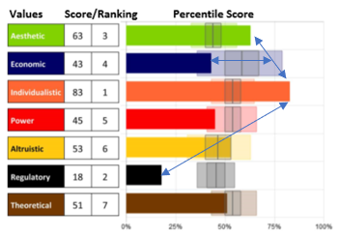
A drive to stand out and be independent and unique.
One's need to be seen as autonomous, unique, independent, and to stand apart from the crowd. Socially independent.

- Very High - Need to be seen – autonomous, unique, independent, stand out, opportunity for self-expression, freedom
- High - Exists in the world, but not OF the world or ONE with the world – setting self apart from others
- Desires freedom and autonomy from others and their ideas, self-promoting
- Projects themselves bigger than they actually are and constantly adding more to the conversation (last word, another thought), lots of ideas to share
- Wants to stand out, be special - red penny in a jar of pennies
- High - Likely insecure – needs to prove to others they are special; craves external validation
low doesn’t do that – more confident in self, doesn’t need to be recognized/noticed, prefers to blend with others, cooperative

Examples of interactions-
  - High IND, High AES– creative, innovative, out of the box thinker
  - High IND, Low REG – independence and flexibility
  - High IND, low ALT – suspicious of others, self-centered
  - High IND, low D, high S – may feel like a prisoner to circumstance
  - High IND, low ALT – individual worker, separate from others
Low IND, high ALT – collaborative, cooperative

POWER – Controlling
The Controller

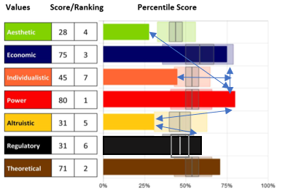
The drive to have control and influence self, other people, environment and space.
One's need to be seen as a leader, to have influence over environment, destiny and success

- High – need to establish control
Low- need to relinquish control
- Competitiveness is often associated
- Wants authority greater to or equal to responsibility, wants to be in charge
- High POW – takes what they want/need
low POW – will accept but won’t take
- High POW – less desire to understand others’ opinions or situations
low POW- strong desire to support others’ efforts, do not want responsibility of leading, owning their space or destiny

Examples of interactions-
  - High POW, high REG and High D – passive aggressive, but no one sees it coming
also seen as Taskmaster, enforcer
  - High POW, Low IND, High ECO – very confident
  - High POW, Low ALT – guarded, suspicious of others (“what do you want from me?”) - they have an agenda so others must too
  - Low POW, low ECO – no agenda
  - Low POW, low ECO, high ALT – Settles for less, doesn’t fight for what they want

ALTRUISTIC – Empathetic
The Compulsive Caregiver

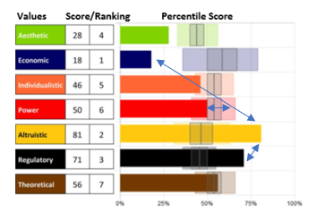
The drive to help further others at the expense of self.
One's need to help others, and eliminate pain and suffering in others
- Need to benefit others at the expense of self
- Personal sacrifice – I lose; you win which means I win
- High degree of energy and importance put into others, less on self
- Sometimes genuine sincerity to help, but often self-worth is low – they help to feel as though they are contributing, earning their keep, bringing value
- Associated with empathy – feelings of others are easily understood and felt too
- Often associated with high REG
- Often high ALT experiences shame (I am a bad person) versus guilt (I did something bad)
- Low ALT – protects own space, keeps emotional distance, not easily taken advantage of, suspicious

Examples of interactions-
  - High ALT – accommodate and help anyone and everyone
low ALT – accommodate and help those who deserve it
  - High ALT – preoccupied with others
Low ALT – preoccupied with self
  - Low ALT, high IND – me first, you second
Low ALT, high ECO – me first, you last
  - High ALT, low ECO, low POW – settles for what they can get, doesn’t fight for what they want
and with low D – dreams by won’t do it, may feel like a prisoner to circumstances
  - High ALT, low IND – I like it when you are the star and I don’t need to be

REGULATORY – Regulated
The Traditional

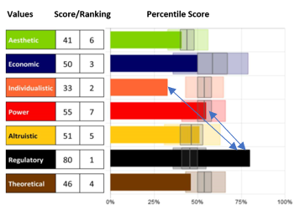
The drive to establish order, routine and structure.
This motivation is to promote a black & white mindset and a traditional/reliable approach to problems and challenges through standards, rules, boundaries and protocols in their own lives and in the lives of others.
  - Need to establish order, routine, structure – High is dependent on rules, low is independent of rules
  - Traditional, conventional approach to problems and challenges through protocol and standards
  - Doing things right in a structured world, following established pathways and enforcing strict guidelines on others
  - More narrow-minded thinking - values concrete, proven methods
  - Not always a rule follower – if they break a rule, they will justify why it didn’t make sense or didn’t apply.
  - Low REG – to each his own attitude, less structured, more open and flexible – independent of the restrictions

Examples of interactions-
  - High REG – enforcers
Low REG – resistant to established norms, don’t care – just get it done
  - High REG, high POW, low ALT – my way or the highway – only 1 way to get it done right
  - Low REG, Low IND- many ways to get it done, lots of options
  - Low REG, high IND and Low C – support each other,
High C is a conflict with low REG and high IND
  - High REG, high ALT – cause driven, doing the “right thing”

IMPORTANT: This dimension has a compressed scale, with very high above 55 and very low below 38. The scale is compressed because the population is becoming more open-minded – making choices about what is right for them as individuals versus what they are “supposed to do” based on social norms/constructs.
THEORETICAL- Investigative
The Teacher

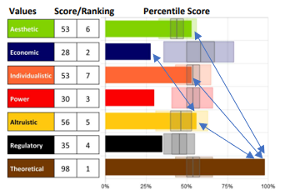
The drive for knowledge, learning and understanding.
The capacity and desire to uncover, discover, and recover the "truth.” This need to gain knowledge for knowledge sake is the result of an “itchy” brain.

- Need to know –
High needs to gather all facts and data before moving forward
Low uses a more relaxed, intuitive approach to information and discovery and only gathers what they need to know based on situation
- Rational thinking, logic, reasoning and problem solving are important to this dimension. This is all about the “need” to know
- Likes complex problems – wants to learn more and understand better and know everything that can be known about what they believe is important

Examples of interactions-
  - Very High AES, Very High THE – experimental people, alternative lifestyles (wants to try interesting things just to know what happens)
  - High THE – complicated, analyzers, thinkers, skeptical, investigators
Low THE – scans, situational learner, easily tricked, trial and error learners, learn through living, don’t like to do homework/research, makes assumptions, struggles with retention
  - High THE – frontal brain – relies on info, data and proof – risk averse
Low THE – limbic brain - relies on feeling, intuition or guessing rather than knowing – risk taker
  - Very High THE (over 75%) – fear of not knowing, being/appearing stupid
  - High THE, High IND, High ALT – most likely a teacher
  - High THE and High C – analysis paralysis
  - When logic driven, High THE may find it difficult to connect to others and become socially inept while conversing with the “lower” thinkers

